Library Mgnt. System Design

This system adopts desktop application concept. It is meant to be applied independently by librarians to manage the library, thus no synchronization is within consideration for the moment being. Also there are some other assumptions for simplify purpose as following:
- One borrower can have a unique card id, which is one SSN can only have one card id;
- One borrower can loan 3 books at most for one time being;
- One ISBN has only one copy;
- Books loaned are due after 14 days of the date out;
- Overdue books are fined at a rate of 0.25 dollar/day from the day after due day;
- Before a book is checked in, fines cannot be paid;
- When fines are paid partly or fully, the fines will stop grow, otherwise the fines grow automatically by day;
- Database Design :
Mysql database is applied here, the schema as following:
a sql script Library.sql is applied first to install the database Library and tables.
Also, there is a DbInitialize.java class as the figure below shows to initialize the database and tables with books.csv and borrowers.csv
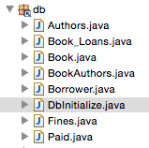
SqlConnect.java is a class to create a connection using JDBC to connect to the database whenever need.

during the initialization, javacsv.jar is applied to help make the file read easier.
- View Design:
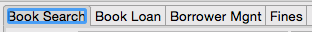
four tabs are applied to 4 main functions of the system, namely book query, book loan(check out/check in), borrower create, fines.
  - book query
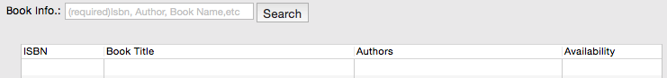
book query can be operated via ISBN, author, book name, or any combinations of them, split by “,”
  - book loan-check out
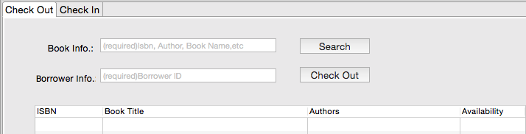
book can be queried via ISBN, author, book name, or any combinations of them, split by “,”first, select any record, input the borrower id, a book can be checked out once. A book loan record will be created.
  - book loan-check in
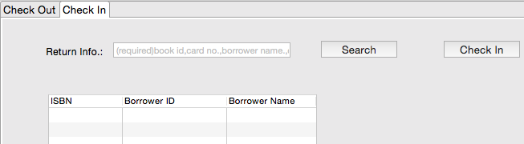
a book can be queried via book ISBN, borrower card id, borrower name, or any combinations of them, split by “,”, select any record, a book can be checked in once. The book loan record will be updated with the date in.
  - borrower management
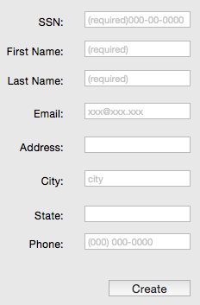
with a valid SSN, first name and last name, a new card id will be created with the info. input.
  - fines
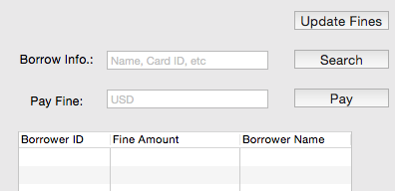
Clicking“Update Fines”will update the overdue books and calculate the fines automatically to the date.
A borrower’s fines can be accessed via name, card id or combination of both.
Select any record, input the fines to pay, the fine amount will deduct automatically. A new FINES record and a new PAID record will be created or updated.
- Controller Design
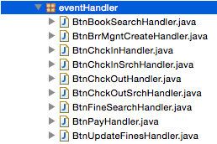
each button has event handler class to realize specific functions.

